;l

Foundations of Programming

Assignment No. : 4
- PROBLEM STATEMENT: Write a C Program to calculate the salary of an employee given his basic pay (taken as input from the user). Calculate gross salary of employee. Let HRA be 10 % of basic pay and TA be 5% of basic pay. Let employees pay professional tax as 2% of total salary. Calculate net salary payable after deductions.

OBJECTIVE:

- To understand the importance of flowchart for any programming model.
- To learn simple flowchart symbols and arrows to define relationships.
- To understand and develop visual representations of flow of data.

THEORY:
- Define Algorithm.
- What are the different characteristics of an algorithm.
PLATFORM: Linux

Code :

#include <stdio.h>

int main() {
float basic, hra, ta, gross, prof_tax, net;

printf("Enter Basic Pay: ");
scanf("%f", &basic);

hra = 0.10 * basic;
ta = 0.05 * basic;
gross = basic + hra + ta;
prof_tax = 0.02 * gross;
net = gross - prof_tax;

printf("\n--- Salary Breakdown ---\n");
printf("Basic Pay : %.2f\n", basic);
printf("HRA (10%%) : %.2f\n", hra);
printf("TA (5%%) : %.2f\n", ta);
printf("Gross Salary : %.2f\n", gross);
printf("Professional Tax : %.2f\n", prof_tax);
printf("Net Salary : %.2f\n", net);

return 0;
}

Flowchart :

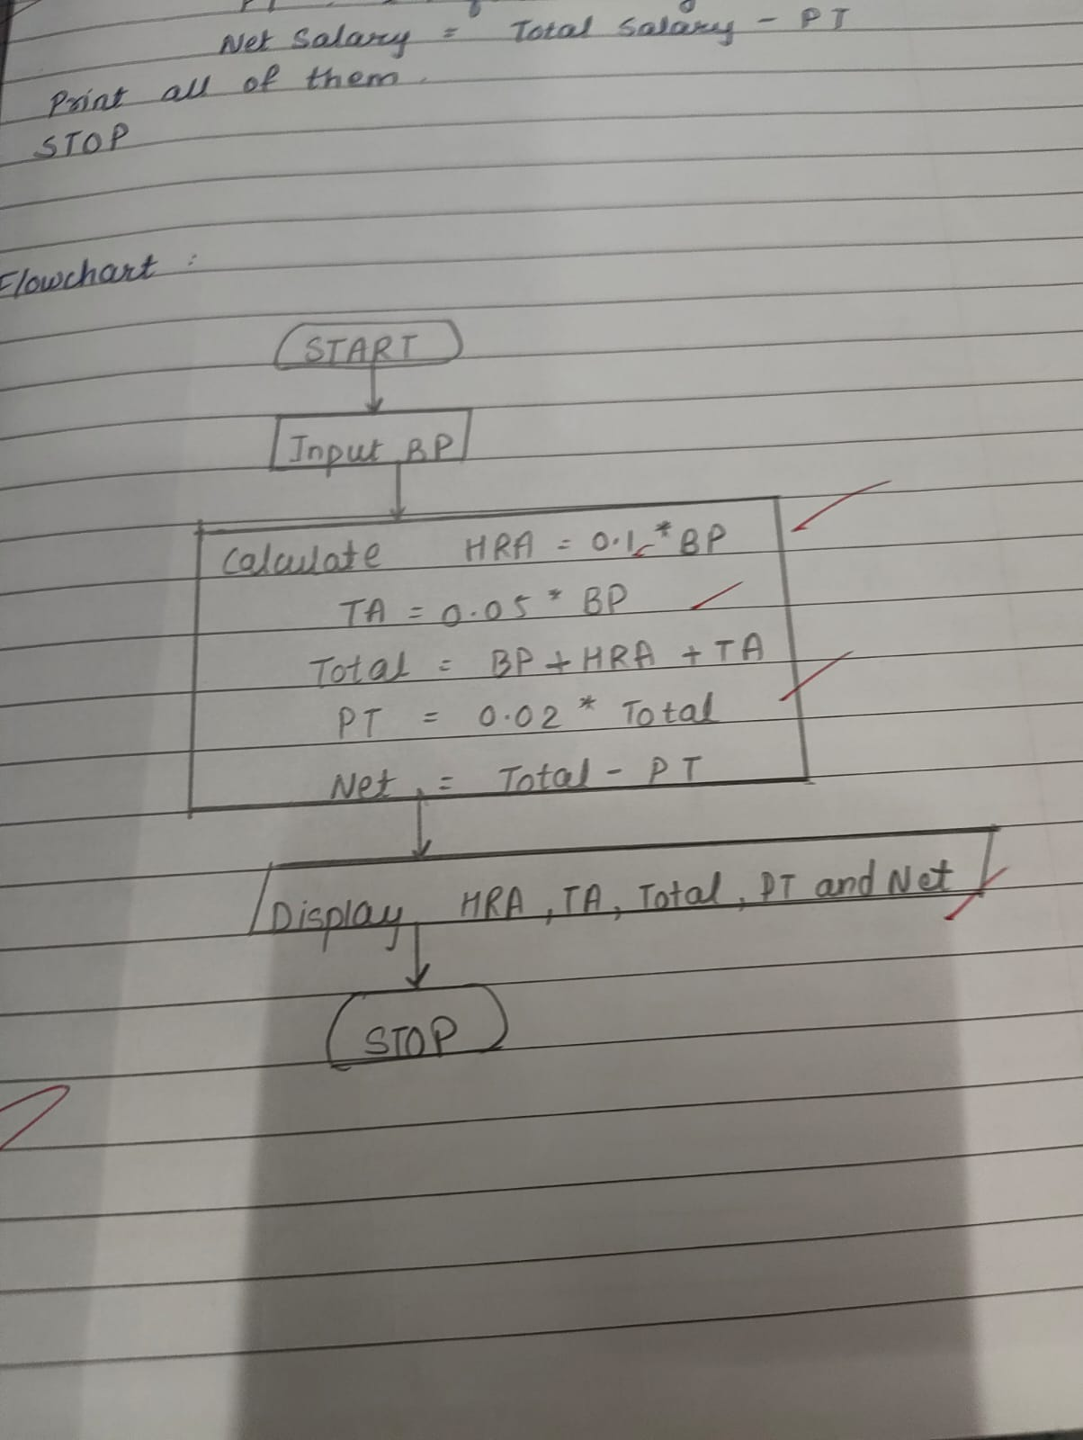

Algo :

Step 1: START
Step 2: Declare variables — basic, hra, ta, gross, prof_tax, net
Step 3: Input basic (Basic Pay from user)
Step 4: Calculate allowances
- hra = 0.10 × basic
- ta = 0.05 × basic
Step 5: Calculate Gross Salary
- gross = basic + hra + ta
Step 6: Calculate Professional Tax
- prof_tax = 0.02 × gross
Step 7: Calculate Net Salary
- net = gross - prof_tax
Step 8: Output
- Print basic, hra, ta, gross, prof_tax, net
Step 9: STOP

INPUT: 56000
OUTPUT:
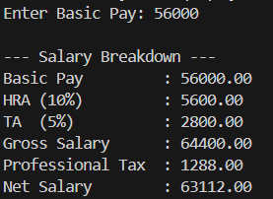
CONCLUSION: Thus, we have learned to write algorithms and to draw its representation in terms of flowchart.

FAQs:
- Describe various symbols and their use in flowchart.
- Difference between Algorithm and Flowchart.

